**Assignment 3**

1. **TV script generation**

We tried generating TV generation model in Keras by using LSTM network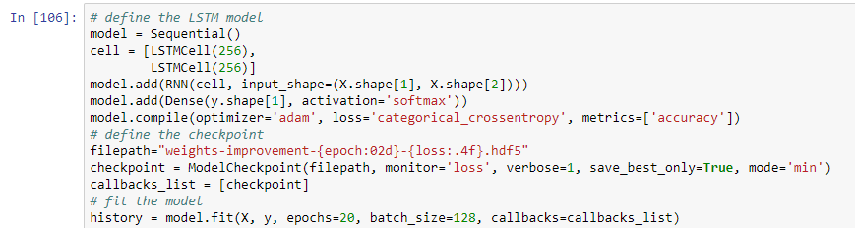

With 50 epochs and batch size of 128 we could minimize the loss to 7.6164 and generate a new script which was somewhat relevant to the script

1. **Language translation**

We implemented a pair of encoder and decoder in Keras which takes input as English and French text

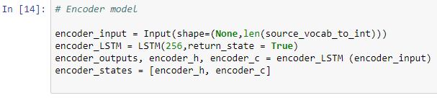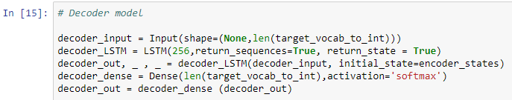

Training for 50 epochs, we could minimize training loss to 0.0011 and validation loss to 0.013

1. **Face Generation**

We implemented GANs to generate faces from celebrity faces in Keras. We built a generator and a Discriminator model which looks like this

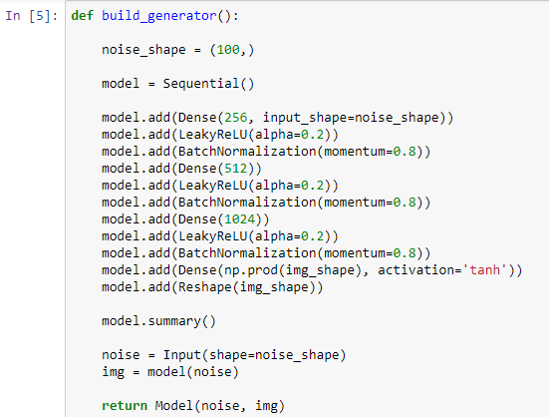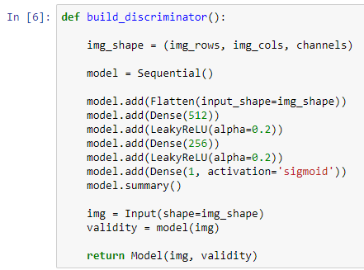

Output produced from this network looks something like this:

